HanYi Wang
hanyi@utexas.edu
Mukul M. Sharma
msharma@mail.utexas.edu
Abstract
Diagnostic Fracture Injection Tests (DFITs) can provide diagnostic information on hydraulic fracturing parameters and reservoir properties. DFIT-Pro Simulator solves the transient flow problem of a closing fracture with variable fracture compliance and fracture pressure dependent leak-off
DFIT-Pro Simulator
Technical Documentation
Summary

This Technical Documentation for DFIT-Pro Simulator is prepared to help users understand background information, theories, and application examples of the hydraulic fracture diagnostics by the analysis of DFIT signatures.

Key References

- Wang, H., Yi,S., and Sharma, M.M. 2018. A Computationally Efficient Approach to Modeling Contact Problems and Fracture Closure Using Superposition Method. Theoretical and Applied Fracture Mechanics, Vol(93): 276-287. https://doi.org/10.1016/j.tafmec.2017.09.009
- Wang, H and Sharma, M.M. 2017. A Non-Local Model for Fracture Closure on Rough Fracture Faces and Asperities. Journal of Petroleum Science and Engineering, Vol (154):425-437. http://dx.doi.org/ 10.1016/j.petrol.2017.04.024
- Wang, H and Sharma, M.M. 2018. Estimating Fracture Closure Stress in Naturally Fractured Reservoirs with Diagnostic Fracture Injection Tests. Paper ARMA-2018-225 presented at the 52nd US Rock Mechanics / Geomechanics Symposium, held in Seattle, Washington, June 17-20.
- Wang, H and Sharma, M.M. 2018. Estimating Unpropped Fracture Conductivity and Compliance from Diagnostic Fracture Injection Tests. Paper SPE 189844 presented at the SPE Hydraulic Fracturing Technology Conference and Exhibition, The Woodlands, Texas, 23 - 25 Jan. http://dx.doi.org/10.2118/ 189844-MS.
- Wang, H and Sharma, M.M. 2017. New Variable Compliance Method for Estimating Closure Stress and Fracture Compliance from DFIT data. Paper SPE 187348 presented at the SPE Annual Technical Conference and Exhibition held in San Antonio, TX, USA, 09 – 11 October. http://dx.doi.org/10.2118/ 187348-MS

Last Updated

on Apri 20, 2018 for DFIT-Pro Simulator 1.0

License Information

This software documentation is provided for internal use only by companies have a license agreement to use this software. The license is non-exclusive, non-sub-licensable, non-transferable and non-assignable.

Contents
Chapter 1: Introduction 4
Chapter 2: Variable Fracture Compliance 6
2.1 The Cause of Variable Fracture Compliance 6
2.2 MODEL FRACTURE CLOSURE AND VARIALBE FRACTURE COMPLIANCE 8
2.3 Relate fracture surface roughness to conductivity 11
Chapter 3: Time Convolution Solution for DFIT 12
Chapter 4: Sensitivity Analysis of Synthetic Cases 15
Chapter 5: Examples of Field Cases Analysis 23
5.1 FIELD CASE 1 23
5.2 FILED CASE 2 26
References 28

Chapter 1: Introduction
Diagnostic fracture injection tests (DFIT) involve pumping a fluid (typically water), at a constant rate for a short period of time, creating a relatively small hydraulic fracture before the well is shut in. The pressure transient data after shut-in is analyzed to obtain in-situ stresses, fracturing treatment design parameters and reservoir properties. The reservoir properties determined by DFIT are representative, because the created fracture can pass through near-wellbore damage zone and provide a large volume of investigation for true formation properties. In addition, the net pressure trends in a DFIT can be also used to infer the induced fracture complexity in different geological settings (Potocki 2012). Thoese valuable information obtained from DFITs provides key input parameters for modeling hydraulic fracture propagation (Wang et al. 2016), stimulation design (Ramurthy et al. 2011), development of reservoir models (Mirani et al. 2016; Loughry et al. 2015), post-fracture analysis (Fu et al. 2017) and estimate stress-dependent un-propped fracture conductivity (Wang and Sharma 2018).

A typical pressure trend is qualitatively shown in Fig.1.1. The pressure decline data after shut-in can be divided into two distinct regions for analysis: before-closure pressure data and after-closure pressure data (separated by the fracture closure pressure). Analysis models are developed differently for these regimes. Before closure analysis (BCA) assumes Carter’s leak-off (Nolte 1979 and1986) and constant fracture compliance or stiffness (Mayerhofer et al. 1995; Valko´ and Economides 1999). Fracture compliance and stiffness (because fracture stiffness is the reciprocal of fracture compliance, they will be used interchangeably throughout this article) reflects the compressibility of fracture. After closure analysis (ACA) assumes the fracture is static with zero fracture compliance or infinite fracture stiffness (Benelkadi and Tiab 2004; Gu et al. 1993; Nolte et al. 1997; Soliman et al. 2005; Soliman and Kabir 2012). Because both BCA and ACA only use some portion of the DFIT data, global consistency of interpretation can’t be guaranteed, even if the individual analyses match a certain portion of the data well. Liu et al. (2016) and Marongiu-Porcu et al. (2014) attempted to bridge BCA and ACA on a log-log plot with polynomial curve fitting and the fracture closure process follows a 3/2 slope on the pressure derivative. However, their work is still based on G-function model’s assumptions and the 3/2 slope just arises from a spatial integration of Carter’s leak-off assumption, which has nothing to do with flow regime or closure stress (McClure 2017; van den Hoak 2017),

The advent of fracturing pressure decline analysis was pioneered by the work of Nolte (1979 and1986). With the assumptions of power law fracture growth, negligible spurt loss, constant fracture surface area after shut-in and Carter’s leak-off model (one-dimensional leak-off of fluid from a constant pressure boundary, the solution to the diffusivity equation predicts that the leak-off rate will scale with the inverse of the square root of time), a remarkably simple and useful equation for the pressure decline can be obtained:
$$P_{f}\left({∆t}_{D}\right)=ISIP-\frac{πr_{p}C_{L}S_{f}\sqrt{t_{p}}}{2}G\left({∆t}_{D}\right) (1)$$

Here, $ISIP$ is the instantaneous shut-in pressure at the end of pumping, $P_{f}$ is the fracture pressure at dimensionless time ${∆t}_{D}$.$t_{p}$ is the total pumping time. $r_{p}$ is the productive fracture ratio, which is the ratio of fracture surface area that is subject to leak-off to the total fracture surface area. For low permeability, unconventional reservoirs, $r_{p}≈$1. To increase the readability of this article, $r_{p}$ will be assumed to be 1 for the rest of the discussion. $C_{L}$ is Carter’s leak-off coefficient which is a constant. $S_{f}$ is the fracture stiffness, which can be calculated using Table 1 for different fracture geometries. It is assumed that $S_{f}$ is a constant until the fracture closes instantaneously when the fluid pressure in the fracture reaches the closure pressure. Because fracture stiffness is the reciprocal of fracture compliance, they will be used interchangeably throughout this article.

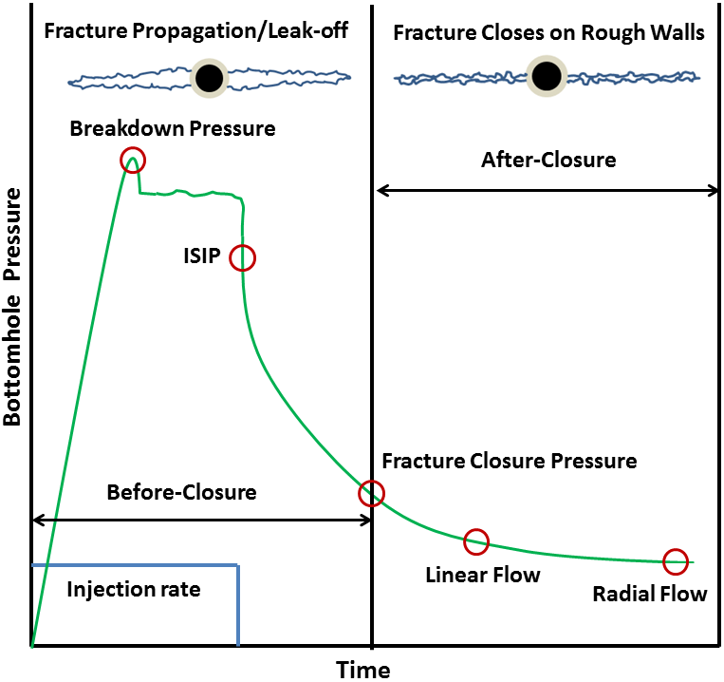

Figure 1.1: Diagram showing sequence of events observed in a DFIT

Fracture Geometry | PKN | KGD | Radial
$$S_{f}$$ | $$\frac{2E'}{πh_{f}}$$ | $$\frac{E'}{{πx}_{f}}$$ | $$\frac{3πE'}{16R_{f}}$$
Table 1-Fracture stiffness expressions for different fracture geometry models

$E^{'}$ is the plane strain Young’s modulus and can be calculated using Young’s Modulus,$E$ , and Poisson’s Ratio, $υ$ :

$$E^{'}=\frac{E}{1-υ^{2}} (2)$$

The dimensionless time ${Δt}_{D}$ is defined by:

$${Δt}_{D}=\frac{Δt}{t_{e}} =\frac{t-t_{e}}{t_{e}} (3)$$

Where t is the generic time and $t_{e}$ is the time at the end of pumping. G-function is defined as

$$G\left({Δt}_{D}\right)=\frac{4}{π}\left[g\left({Δt}_{D}\right)-g\left(0\right)\right] (4)$$

Where the g-function of time is approximated by,

$$g\left({Δt}_{D}\right)=\left\{\begin{aligned}{(1+Δt}_{D})\sin^{-1}{{(1+Δt}_{D})}^{-1/2}+{{Δt}_{D}}^{1/2} for low fluid efficiency \\ \frac{4}{3}\left[{{(1+Δt}_{D})}^{1.5}-{{Δt}_{D}}^{1.5}\right] for high fluid efficiency\end{aligned}\right. (5)$$

From Eq.(1), we can infer that for normal leak-off behavior (constant Carter’s leak-off coefficient, constant leak-off area and constant fracture stiffness during fracture closure), the pressure declines linearly with $G\left({∆t}_{D}\right)$. Castillo (1987) used Nolte's G-function for modeling the pressure decline behavior and developed the straight-line plot of the G-function vs. pressure. The slope of this curve is used for the computation of the leak-off coefficient that is independent of pressure. Any departure from this straight-line is interpreted as closure of the fracture.
Unfortunately, plots of pressure versus G-function often yield curves with multiple points of inflection that have been attributed to abnormal leak-off behavior (such as pressure dependent leak-off, fracture height recession, closing of secondary transverse fractures, and fracture tip extension), which makes it difficult to interpret the changes in slope and identify fracture closure. So identification of fracture closure pressure and non-ideal behavior is usually done using plots of pressure and GdP/dG versus G-function (Barree and Mukherjee, 1996; Barree, 1998, Barree et al., 2014), where the closure is picked at the tangential point between a straight line that passes the origin and the GdP/dG curve. This prevailing method of determining minimum in-situ stress (although has been widely accepted, but has never been theoretically proved) will be classified and discussed as “tangent line method” in the following text. The fracturing pressure decline model that underlying G-function plot suffers from two distinct and important issues: (1) leak-off is not pressure-dependent, i.e. a constant pressure boundary is assumed (2) fracture compliance/stiffness is assumed to be constant during fracture closure. This is why G-function based models are only used for before closure analysis and are not capable of analyzing DFIT data from the end of pumping to days or even weeks after shut-in, which requires bridging both before and after closure data seamlessly.

Chapter 2: Variable Fracture Compliance

2.1 The Cause of Variable Fracture Compliance
There are basically two main causes that lead the continuously changing of fracture compliance during closure. The first is stress contrast across different layers that the fracture has penetrated into. In this case, fracture will close first in the zones where the minimum in-situ stress is highest, which alters the overall fracture stiffness during the closure process. The second cause of variable fracture compliance is fracture surface asperities and roughness, where the fracture closes on asperities progressively from its edges to the center, and the overall fracture stiffness is determined by both the closed portion and open portion of fracture during closure.
As pressure declines inside the fracture after shut-in, the fracture will gradually close and the fracture aperture will approach the scale of the surface roughness. If the fracture faces are perfectly parallel and smooth, they will come into contact all at once when the fluid pressure inside the fracture declines to the far field stress, and the fracture is then mechanically and hydraulically closed. However, there is abundant evidence to suggest that fractures retain their conductivity after the walls have come into contact (mechanical closure). Fractures retain a finite aperture after mechanical closure due to a mismatch of asperities on the fracture walls. van Dam et al. (2000) presented scaled laboratory experiments on hydraulic fracture closure behavior. They observed up to a 15% residual aperture (compared to the maximum aperture during fracture propagation) long after shut-in. Fredd et al. (2000) demonstrated fracture surface asperities can provide residual fracture width and sufficient conductivity in the absence of proppants. Using sandstone cores from the East Texas Cotton Valley formation, sheared fracture surface asperities that had an average height of about 2.286 mm were observed. Warpinski et al. (1993) reported hydraulic fracture surface asperities of about 1.016 mm and 4.064 mm for nearly homogeneous sandstones and sandstones with coal and clay-rich bedding planes, respectively. Sakaguchi et al. (2008) created tensile fractures in large rock blocks and measured the asperity height and distribution. Their work shows that the fracture surfaces can be assumed to be a fractal object and most of the asperities fall within 1 to 2 mm in height. Wells and Davatzes (2015) conducted topographic measurement on dilated fractures from core samples and found the asperity height ranges from hundreds to thousands of micrometers. Bhide et al. (2014) created X-ray microtomographic images from shear induced fractures and the roughness values obtained varied from 1.8 to 1.95 mm along the length of the rock samples. Zou et al. (2015) conducted experiments on 20 fractured shale samples and found the average asperity height to be 1.88 mm. An experimental study (Zhang et al. 2014) on Barnett Shale samples reveals that the surface topography of the displaced fracture can be altered because of rock failure, and the fracture surface exhibited parallel strips of crushed asperities. Field measurements (Warpinski et al. 2002) using a down-hole tiltmeter array indicated that the fracture closure process is a smooth, continuous one which often leaves 20%-30% residual fracture width, regardless of whether the injection fluid is water, linear-gel or cross-linked-gel.

Fig.2.1 shows the tiltmeter measurement (measure the deformation during fracture closure and is proportional to average fracture width and fracture volume, its slope is proportional to fracture compliance or inversely proportional to fracture stiffness) from GRI/DOE M-site project and the corresponding progressive fracture closure behavior (the scale of fracture surface asperities is enlarged for demonstrate rough fracture surface). These data are collected from the end of pumping to weeks of shut-in, where the fracture has been closed for a long time. When pressure inside the fracture is above 21 MPa, the measured tilt declines linearly with pressure. The fracture can be considered as an open fracture during this period and its stiffness is constant and can be calculated using Table 1 for different geometries. When pressure drops below 21 MPa, the measured tilt start to deviate from the straight, this is because at this point, fracture start to closure on asperities on fracture edges or tips. As pressure continues to decline, more and more fracture surface come into contact on asperities and the fracture stiffness gradually increases, because the fracture as whole is losing its compressibility. After all the fracture surfaces have come into contact, the closed fracture stiffness is dominated by the properties of the asperities, which support the residual fracture width. In essence, fracture compliance or stiffness represents fracture compressibility that is normalized by fracture surface area. Conventionally, the fracture surface is assumed to be perfect smooth, if this is the case, then the normalized tilt should decline linearly with pressure all the way to closure stress, where normalized tilt equals to zero. In such case, the fracture stiffness remains a constant value and increases to infinite abruptly when pressure drops to closure stress, which is not what the tiltmeter measurement indicates.

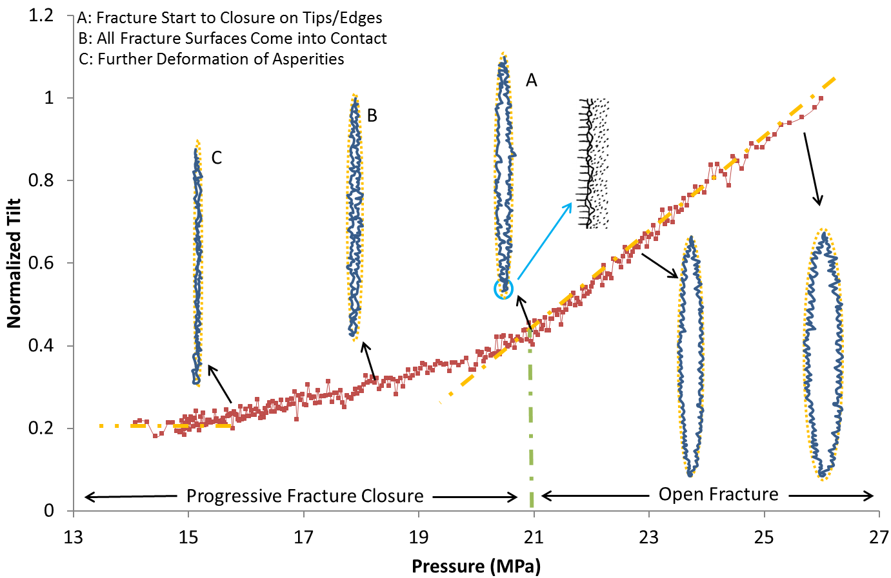

Figure 2.1: Normalized tiltmeter data from shut-in of 2B from the GRI/DOE M-site and corresponding progressive fracture closure behavior

Post shut-in water hammer pressure signals from hydraulically fractured wells were analyzed. The period, amplitude, and decay rate of the pressure signal were the three characteristic properties chosen for analysis. The three characteristic properties were compared to production log and micro-seismic SRV data to identify any correlations.

2.2 MODEL FRACTURE CLOSURE AND VARIALBE FRACTURE COMPLIANCE
The microscopic measurement and modeling of surface roughness and mechanical properties of asperities can often be up-scaled to macroscopic contact laws that relate fracture width and the associated contact stress. Willis-Richards et al. (1996) proposed contact law to relate fracture width and the net closure stress for fractured rocks, based on the work of Barton et al. (1985):

$σ_{c}=\frac{σ_{ref}}{9}\left(\frac{w_{0}}{w_{f}}-1\right)for w_{f}≤w_{0} (6)$

where $w_{f}$ is the fracture aperture and, $w_{0}$is the contact width, which represents the fracture aperture when the contact normal stress is equal to zero, $σ_{c}$ is the contact normal stress on the fracture, and $σ_{ref}$ is a contact reference stress, which denotes the effective normal stress at which the aperture is reduced by 90%. it should be emphasized that the contact width $w_{0}$ is determined by the tallest asperities, and the strength, spatial and height distribution of asperities are reflected by the contact reference stress $σ_{ref}$ (e.g., if the tallest asperities on two fracture samples are the same, then they should have the same $w_{0}$, but the one with a higher median asperity height or Young’s modulus will have higher value of $σ_{ref}$, provided other properties are the same).

With known fracture geometry, rock properties and surface roughness (represented by contact parameters $w_{0}$ and $σ_{ref}$), the question now is how to estimate fracture stiffness (or compliance) as a function of pressure, if it continuously changes during fracture closure. Wang and Sharma (2017) presented an integral transform method and general algorithms to model the dynamic behavior of hydraulic fracture closure on rough fracture surfaces and asperities, using linear elastic solutions that coupled with contact law for three different fracture models (PKN, KGD and radial fracture geometry). Given the fracture geometry, rock properties, contact parameters and minimum principal stress, their approach can predict the evolution of fracture aperture profile, total fracture volume and fracture stiffness as fracturing pressure declines. Wang et al. (2017) presented an improved model for fracture closure based on superposition principles. Their model can simulate large scale fracture closure behavior with layer stress contrast in an efficient manner.
Detailed modeling of non-local fracture closure on asperities and rough surfaces has already been discussed extensively (Wang and Sharma 2017; Wang et al. 2017), hence will not be discuss further. Here, we’ll examine an example of a fracture that closes on asperities and how the fracture stiffness evolves during closure. Assuming a Young's modulus of 20 GPa, Poisson's ratio of 0.25, $w_{0}$ of 2 mm, $σ_{ref}$ of 5 MPa for a PKN fracture geometry with 10 m fracture height, 35 MPa minimum in-situ stress, the evolution of the fracture width profile and contact stress distribution can be determined, as the fluid pressure inside the fracture gradually declines. The results are shown in Fig.2.2 and Fig.2.3. To demonstrate the impact of fracture roughness and surface asperities on fracture closure behavior, the case without surface asperities (fracture surface is completely planar and smooth) is also included. The result shows that at relative high fracturing fluid pressure, the fracture asperities have negligible impact on fracture width distribution, and the contact stress is always concentrated at the tip of the fracture, where the contact stress is much higher than in the middle of the fracture. We can also see that the fracture surfaces do not contact each other like parallel plates. In fact, the fracture closes on rough surfaces starting from the tip, and closes progressively all the way from the edges to the center of fracture. As fluid pressure continues to decline, more and more of the fracture surfaces come into contact and these changes the subsequent fracture closure behavior. At lower fluid pressures, contact stresses start to counter-balance the in-situ stress and the fracture becomes stiffer and less compliant. If the fracture faces were perfectly parallel and smooth, the fracture width would have collapsed to zero when the fluid pressure dropped to 35 MPa. The moment when all fracture surfaces come into contact on asperities and the contact stress becomes non-zero on the entire fracture surface, the fracture is mechanically closed and this mechanical closure stress is higher than the minimum in-situ stress.
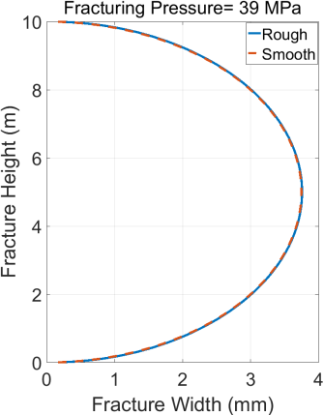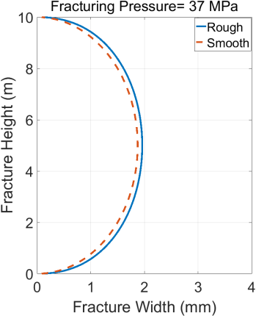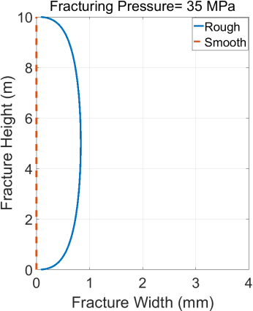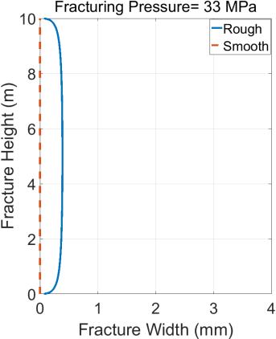
Fig.2.2 Fracture width evolution with and without asperities at different fluid pressure for a PKN geometry
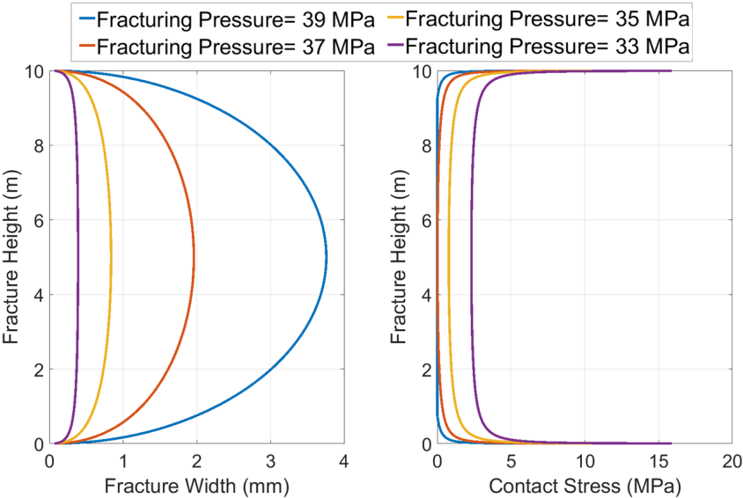
Fig.2.3 Fracture width and the corresponding contact stress distribution at different fluid pressure for a PKN geometry
The simulated fracture volume evolution as a function of fluid pressure is shown in Fig.2.4. As can be seen, when the fluid pressure inside the fracture is relatively high, the fracture volume declines linearly with pressure (indicates roughly constant fracture compliance/stiffness). However, as the pressure declines to a certain level (2 MPa higher than the input minimum in-situ stress of 35 MPa), the fracture volume and pressure departs from a linear relationship. The traditional method of estimating fracture stiffness using Table 1 can only be used when the fracture pressure is still relatively high and the asperities are only in contact at the edges of the fracture. However, as pressure declines further and more and more fracture surface area comes into contact, the fracture stiffness becomes pressure dependent:
$$S_{f}=\frac{A_{f}dP_{f}}{dV_{f}} (7)$$

The relationship between $P_{f}$ and $V_{f}$ from the output of non-local fracture closure model can be used to calculate the pressure dependent fracture stiffness and the result is also shown in Fig.2.4.
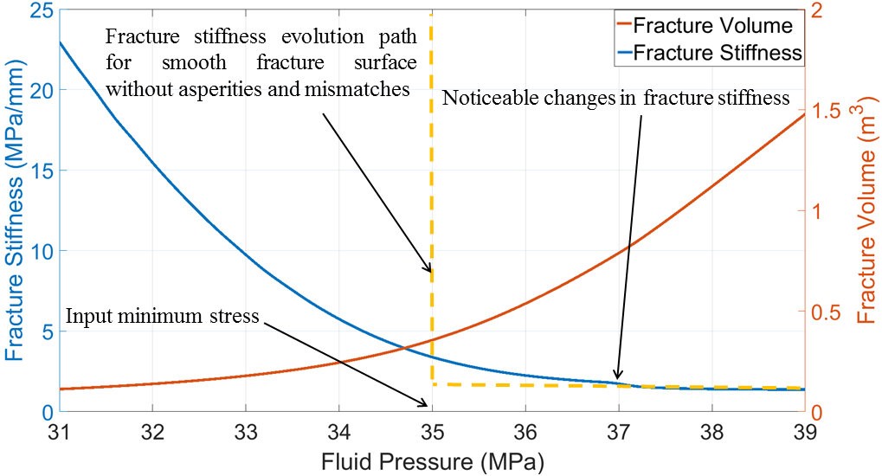
Fig.2.4 Fracture volume and fracture stiffness evolution as fluid pressure declines for a PKN geometry

2.3 Relate fracture surface roughness to conductivity
Knowing the properties of surface roughness (represented by up-scaled contact width $w_{0}$ and contact reference stress $σ_{ref}$), and applying the non-local fracture closure model (Wang and Sharma 2017a; Wang et al 2017), the fracture width profile at any fluid pressure can be determined, regardless of whether the fracture is open, partially closed or completely closed (all asperities have come into contact with stress-dependent residual fracture width). Since the matrix permeability is low and there exists a linear relationship between the flow rate and differential pressure along the fracture during production, the fracture permeability $k_{f}$ can be calculated based on the cubic law (Watanabe et al., 2008):
$$k_{f}=\frac{{w_{f}}^{2}}{12} (8)$$
The fracture conductivity $C_{f}$ is defined as the product of fracture permeability and fracture width:
$$C_{f}=k_{f}w_{f} (9)$$
For a fracture with arbitrary fracture width distribution, as shown in Fig.2.5, the fracture cross section area that is perpendicular to fracture flow can be discretized into a number of sections. In the ith section, the cross-section area is $A_{i}$, the average fracture width is $\overline{w_{f(i)}}$ and the corresponding conductivity is $C_{f(i)}$. To get representative fracture conductivity over the entire fracture cross-section area, an arithmetic average needs to be applied:
$$C_{f}=\frac{\sum_{i=1}^{i=n}{{C_{f(i)}A}_{i}}}{\sum_{i=1}^{i=n}{A_{i}}} (10)$$
Combining Eq.(4) and Eq.(5) into Eq.(6), and assuming the fracture is uniformly discretized in the y-direction, then the calculation of fracture conductivity can be simplified as:
$$C_{f}=\frac{1}{12}\frac{\sum_{i=1}^{i=n}{{\overline{w_{f(i)}}}^{4}}}{\sum_{i=1}^{i=n}{\overline{w_{f(i)}}}} (11)$$
Because fracture geometry, rock mechanical properties and contact parameters uniquely determine the fracture width profile at a given fluid pressure, the fracture conductivity evolution during fracture closure can be estimated once the dynamics of fracture width profile is known. However, the question remains: how can we obtain representative values of contact width $w_{0}$ and contact reference stress $σ_{ref}$ for a field scale fracture, rather than from small scale laboratory experiments. Is it possible to obtain contact parameters from DFIT data? We will examine the impact of surface roughness on pressure response during fracture closure and the possibility of estimating contact parameters by DFIT data in later sections.
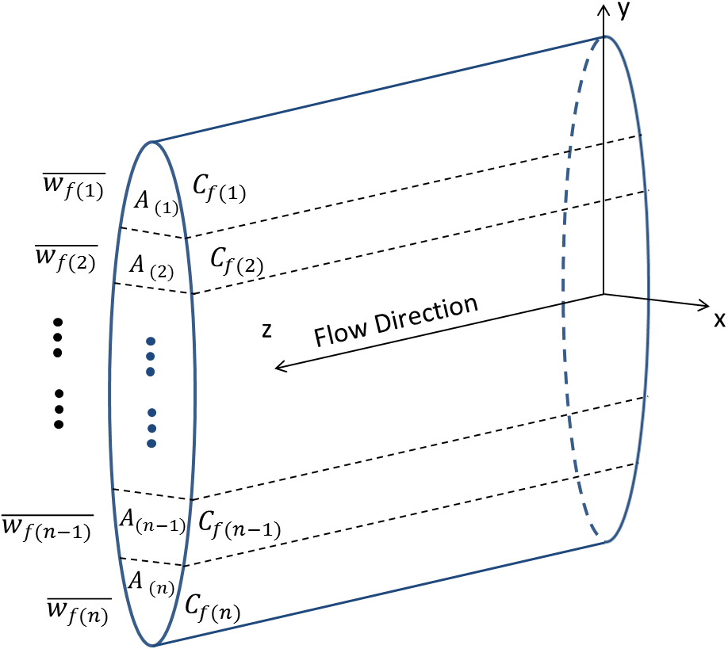
Fig.2.5 Illustration of discretizing cross-section area of fracture flow.

Chapter 3: Time Convolution Solution for DFIT
The pressure transient response during fracture closure is derived using the following assumptions:
- Reservoir is isotropic and homogeneous and contains a single slightly compressible fluid, and the injected fluid has the same properties as the reservoir fluid. This assumption is appropriate as long as the PVT properties used in the DFIT model represent in-situ fluid (Gu et al. 1993; Soliman et al. 2005).
- The fluid viscosity, formation porosity, total compressibility, and rock matrix permeability are independent of pressure.
- Reservoir permeability is low so that poroelastic effects caused by fluid leak-off are negligible
- Gravity effects are negligible.
- Leak-off surface area is constant. This means that mechanically closed fracture still retains hydraulic conductivity because of its residual fracture width that supported by asperities that caused by erosion or distortion of fracture walls.
- The pressure is uniformly distributed inside the fracture. This is the typical case in unconventional reservoirs. The pressure distribution inside fracture can be considered to be uniform after shut-in and during closure, as discussed by Koning et al. (1985). The existence of after-closure linear flow also demonstrates that fracture conductivity can be regarded as infinite when the pressure drop along the fracture is negligible.
- The pore pressure disturbance caused by fracture propagation is negligible. This assumption is reasonable because fluid leak-off during pumping is small and the duration of injection is short (typically 3-10 minutes) while the total shut-in time can be hours, days or even weeks.
- Leak-off is linearly perpendicular to fracture surface and late time radial flow has not been developed yet.
Assuming linear Darcy flow and a slightly compressible, single phase fluid in the reservoir, the differential form of the mass balance can be written as:
$$\frac{μ_{f}ϕc_{t}}{k}\frac{∂P}{∂t}=\frac{∂^{2}P}{∂x^{2}} (12)$$
where $P$ is the pressure, $k$ is formation permeability, $μ_{f}$ is fluid viscosity, $ϕ$ is formation porosity and $c_{t}$ is total formation compressibility. If we assume that a constant fracture pressure $P_{f}$ is applied at the fracture surface, the leak-off velocity $U_{f}$across fracture surface can be found as (Economides and Nolte 2000):
$$U_{f}=\left(P_{f}-P_{0}\right)\sqrt{\frac{kϕc_{t}}{πμ_{f}∆t} } (13)$$
where $P_{0}$ is the initial reservoir pressure. The total leak-off rate $q_{f}$from one wing of the fracture starting from shut-in is
$$q_{f}=2A_{f}(P_{f}-P_{0})\sqrt{\frac{kϕc_{t}}{πμ_{f}∆t} } (14 )$$
where $A_{f}$ is the fracture surface area of one face of one wing of the fracture. If $P_{f}$ is constant, then the leak-off rate $q_{f}$ is proportional to $\frac{1}{\sqrt{∆t }}$, which is the assumption of Carter’s leak-off model. However, $P_{f}$ continues decline during fracture closure, the leak-off rate will deviate from Carter’s leak-off model and turn the pressure derivative downward on G-function and square root of time plots (Wang and Sharma 2017b). To account for the fracture pressure dependent leak-off, pressure superposition is needed. Divide the shut-in time $∆t$ into n time steps, and the leak-off rate at the nth time step can be determined based on superposition:
$$q_{f,n}=2A_{f}\sqrt{\frac{kϕc_{t}}{πμ_{f}} }\sum_{j=1}^{n}{\frac{P_{f,j}-P_{f,j-1}}{\sqrt{{∆t}_{n}-{∆t}_{j-1} }}} (15)$$
The pressure difference $P_{f,j}-P_{f,j-1}$ is the pressure in the fracture at time step j minus the pressure in the formation at the fracture-formation interface, which equals to the pressure in the fracture at the previous time step. From a material balance perspective (fluid compressibility is negligible compared to that of the fracture), the rate of fluid leak-off into the formation,$q_{f }$(one wing of the fracture), after shut-in equals the rate of shrinkage of fracture volume,$V_{f }$(one wing of the fracture), as pressure declines:
$$q_{f}=- \frac{dV_{f}}{dt} (16)$$
And
$$\frac{dV_{f}}{dt}= \frac{d(A_{f}{\overline{w}}_{f})}{dt}= \frac{d(\frac{A_{f}}{S_{f}}P_{net})}{dt}= \frac{d{(\frac{A_{f}}{S_{f}}P}_{f})}{dt} (17)$$
where $\overline{w}$ is the average fracture width, $S_{f}$ is fracture stiffness. Note that by definition, $S_{f}=\frac{A_{f}dP_{f}}{dV_{f}}=\frac{dP_{f}}{d{\overline{w}}_{f}}$ , For open fractures at relative high pressure, $S_{f}$ can be determined analytically using Table-1. For more general circumstances, $S_{f}$ can be calculated numerically as the fracture closes progressively (Wang and Sharma 2017a; Wang et al. 2018), and the numerical solution gives the same results as using the formulae in Table-1 (when the fracture is still open at high pressure).
With the above definitions, Eq.(16) can be re-written as
$$q_{f}=- \frac{d(\frac{A_{f}}{S_{f}}P_{f})}{dt} (18)$$
If we discretize Eq.(18) into small time intervals where the pressure drop is insignificant within each interval, then the term $\frac{A_{f}}{S_{f}}$ can be treated as a constant in each time interval, though the value of $\frac{A_{f}}{S_{f}}$ is pressure-dependent for different time intervals. Discretize Eq.(18) into $q_{f,n}=- \frac{A_{f}}{S_{f,n}}\frac{dP_{f,n}}{{dt}_{n}}$and equate it to Eq.(15), the $A_{f}$ is then canceled out in each time interval:
$$\frac{1}{S_{f,n}}\frac{dP_{f,n}}{d{∆t}_{n}} =-2\sqrt{\frac{kϕc_{t}}{πμ_{f}} }\sum_{j=1}^{n}{\frac{P_{f,j}-P_{f,j-1}}{\sqrt{{∆t}_{n}-{∆t}_{j-1} }}} (19)$$
let$P_{f,0}=P_{0}$, $P_{f,1}=ISIP$, ${∆t}_{1}=0,$then for $n≥2$, integrate Eq.(19) across the discretized data points with respect to shut-in time, we can obtain fracturing pressure with changing fracture stiffness and fracture pressure dependent leak-off based on a time-convolution solution :
$$P_{f,n}=ISIP-4\sqrt{\frac{kϕc_{t}}{πμ_{f}} }\sum_{i=1}^{n-1}{S_{f,i}\sum_{j=1}^{i}{{(P}_{f,j}-P_{f,j-1})(\sqrt{{∆t}_{i}-{∆t}_{j-1}}}}-\sqrt{{∆t}_{i-1}-{∆t}_{j-1}} ) (20)$$
From Eq.(20), we realize that for a given initial condition, reservoir properties and pressure dependent fracture stiffness, the pressure decline response is uniquely determined. In the above derivation, it is assumed that the whole fracture surface area is subject to leak-off, which is the norm in unconventional reservoirs. If only a portion of fracture surface is considered permeable, then one needs to multiply the right side of Eq.(A4) by the productive fracture ratio $r_{p}$. To account for wellbore storage effects, the fracture stiffness $S_{f}$ in Eq.(20) needs to be replaced by the fracture-wellbore system stiffness, which is defined as:
$$S_{s}=\frac{A_{f}}{\frac{A_{f}}{S_{f}}+V_{w} c_{w}}=\frac{S_{f}A_{f}}{A_{f}+S_{f}V_{w} c_{w}} (21)$$
Where $V_{w}$ is half the wellbore volume (only one wing of the fracture needs to be modeled) and $c_{w}$ is the compressibility of water. In essence, the fracture-wellbore system stiffness reflects the fracture surface area normalized system compressibility. From Eq.(21), we can infer that when fracture stiffness is small (fracture compliance is large), the system stiffness is dominated by fracture stiffness, because the fracture has a large compressibility compared to the wellbore. However, as fracture stiffness continues to increase during closure, the wellbore storage will play a more and more important role, and at the end, when fracture stiffness becomes large enough, the system stiffness is controlled entirely by wellbore storage, and becomes independent of pressure. In other literature, the system compressibility sometimes can be referred to as system storage coefficient$C_{s}$:
$$C_{s}=\frac{A_{f}}{S_{s}}=\frac{A_{f}}{S_{f}}+V_{w} c_{w} (22)$$

Chapter 4: Sensitivity Analysis of Synthetic Cases
In this section, Eq.(20) is used to investigate how different fracture geometry, contact parameters and reservoir properties impact the fracture compliance/stiffness evolution and pressure decline response during DFIT, so that we can differentiate the signatures on a pressure transient response that is mostly controlled by fracture surface roughness. Assuming a Base Case scenario where the input parameters are provided in Table 2.
Fracture type | PKN
Fracture height | 10 m
Fracture length | 50 m
Contact width | 2 mm
Contact reference stress | 5 MPa
Pumping time | 5 min
ISIP | 40 MPa
Minimum in-situ stress | 35 MPa
Initial pore pressure | 20 MPa
Reservoir permeability | 0.0005 md
Young's modulus | 20 GPa
Total compressibility | 1.9e-3 MPa-1
Viscosity | 1 cP
Poisson's Ratio | 0.25
Initial porosity | 0.03
Table 2-Input parameters for Base Case scenario
Fig.4.1 shows the contact stress at different local fracture widths. As expected, when the fracture width is larger than the contact width $w_{0}$, the contact stress is zero. However, when the fracture width is smaller than the contact width, the contact stress and fracture width follows a hyperbolic relationship, as reflected by Eq.(6). Fig.4.2 shows the corresponding fracture stiffness evolution based on the solutions of linear elasticity (Wang and Sharma 2017a; Wang et al. 2017), for different $w_{0}$ with the given fracture geometry and rock properties (provided in Table 2). The results indicate that as the fracture width decreases, the rough fracture walls will come into contact sooner if the contact width is larger, so the noticeable changes of fracture stiffness occur earlier when the contact width is larger. We can also observe that when the contact width is larger, the increase in fracture stiffness is more gradual and smooth. In the extreme case when $w_{0}$ is zero, as would be the case for perfectly smooth fracture surfaces, the fracture stiffness will increase abruptly to infinity as soon as the fluid pressure drops to the minimum in-situ stress (35 MPa in this case). This pressure-dependent fracture stiffness can be directly put into Eq.(20) to predict the fracture pressure decline for certain reservoir properties.
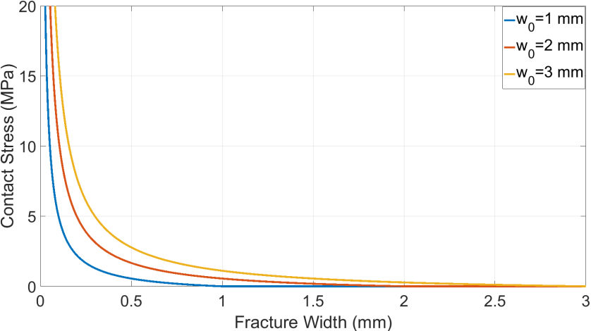
Fig.4.1 The relationship between contact stress and fracture width for different $w_{0}$
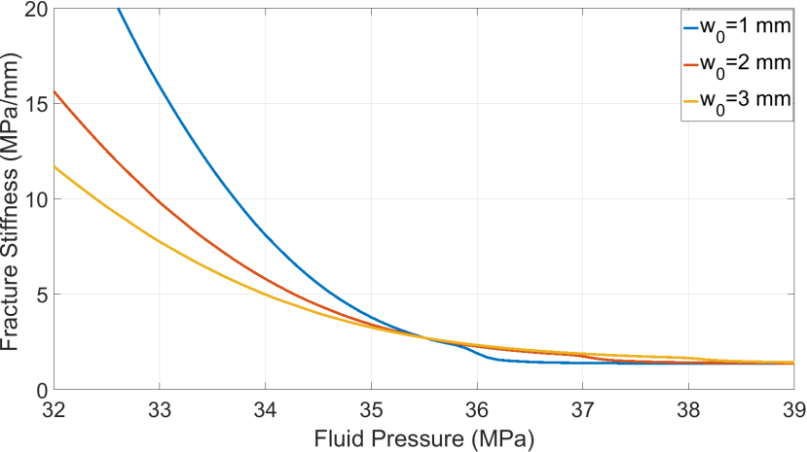
Fig.4.2 Fracture stiffness evolution for different $w_{0}$
Fig.4.3 shows the fracturing pressure and its derivatives for different $w_{0}$ on G-function and square root of time plots. We can notice that the contact width impacts the pressure decline response significantly, because it alters the evolution of the fracture stiffness. Large contact width leads to a smooth pressure decline trend while small contact width leads to steep changes in the pressure decline rate and pressure derivatives. We can also infer that if the contact width is close to zero and all fracture walls come into contact simultaneously, then a sudden change in pressure decline rate and the pressure derivative spikes on both the G-function and square root of time plots. This is unrealistic and never observed in field cases. So the conventional assumption that a fracture closes on flat, smooth fracture surfaces where $w_{0}=0$ does not reflect reality. The most important observation is that at the beginning, pressure and its derivative are not impacted by $w_{0}$. This is because at higher pressure, the fracture walls are still wide open and the contact of asperities at the fracture edges has a negligible influence on the overall fracture stiffness, which is mainly controlled by the initial fracture geometry (as determined in Table 1).
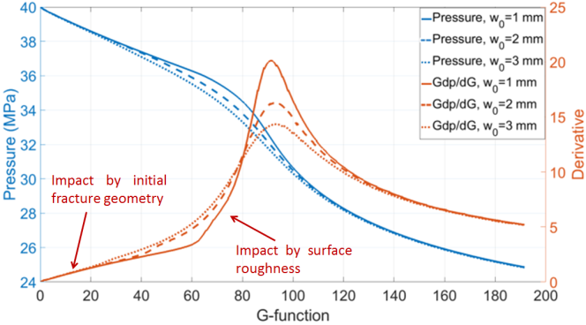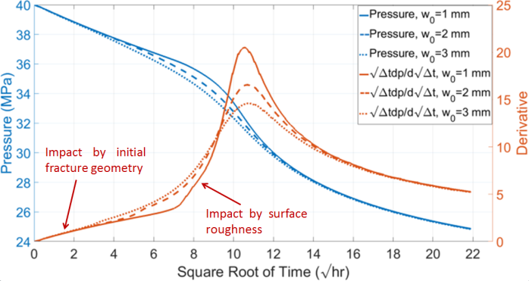
Fig.4.3 Pressure decline response for different $w_{0}$
Fig.4.4 shows the fracture conductivity (1 ${um}^{2}$-cm$≈33$md-ft). as a function of increasing effective stress (far-field minimum in-situ stress minus fluid pressure inside the fracture) for different contact width $w_{0}.$As expected, the larger the $w_{0}$, the higher the fracture conductivity because the overall fracture residual aperture is larger. We can also see that when $w_{0}$ is smaller, the fracture conductivity is more sensitive to an increase in the effective stress.
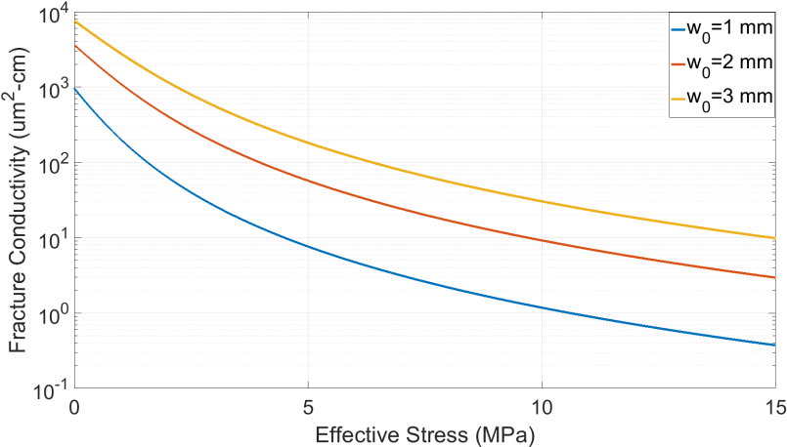
Fig.4.4 Fracture conductivity evolution for different $w_{0}$
Next, we examine how the contact reference stress affects the pressure decline response. Fig.4.5 and Fig.4.6 show the relationship between contact stress and fracture width for different contact reference stress and the corresponding fracture stiffness evolution at different fracturing pressure. For the same contact width, the higher the contact reference stress, the more rapid the increase of contact stress as the fracture width shrinks. Physically, the contact reference stress represents how hard and strong the fracture surface asperities are. The lower the contact reference stress, the more gradual the change in fracture stiffness as pressure declines. Even though the contact reference stress does not have much impact on the pressure at which the fracture stiffness starts to changes noticeably, it does impact the fracture stiffness evolution, as shown in Fig.4.6.

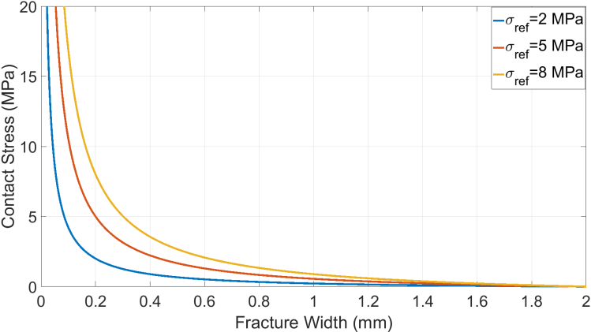
Fig.4.5 The relationship between contact stress and fracture width for different $σ_{ref}$
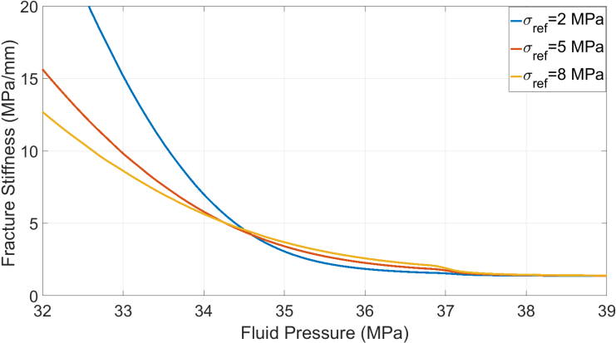
Fig.4.6 Fracture stiffness evolution for different $σ_{ref}$
Fig.4.7 shows the fracturing pressure and its derivatives for different contact reference stress on G-function and the square root of time plots. Again, we can notice that the contact reference stress has negligible influence on early time pressure decline when fracture stiffness is primarily controlled by initial fracture geometry. However, after this period as the fracture pressure declines further, more and more fracture surfaces come into contact and the contact reference stress begins to affect the pressure decline trend and the peak value of the pressure derivatives.
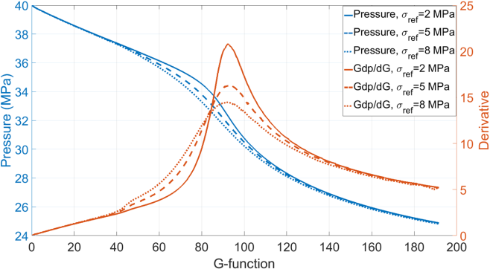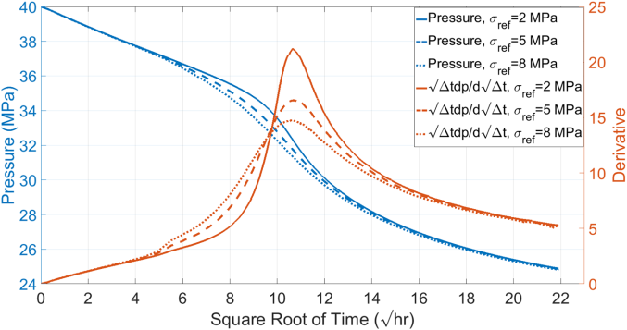
Fig.4.7 Pressure decline response for different$σ_{ref}$
Fig.4.8 shows the fracture conductivity evolution for different reference contact stress $σ_{ref}$. It can be observed that when $σ_{ref}$ is small, fracture conductivity is more sensitive to effective stress, this is because $σ_{ref}$ determines how supportive the asperities are. When $σ_{ref}$ is small, the asperities are more prone to deformation, so the average residual fracture width is smaller at the same level of effective stress.
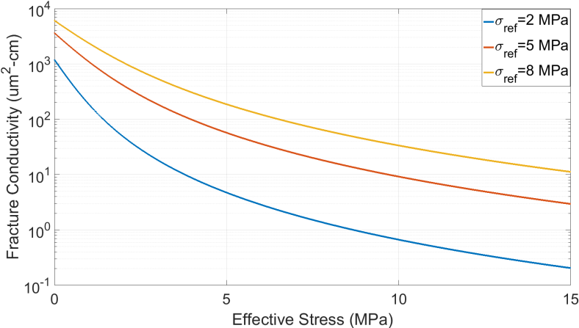
Fig.4.8 Fracture conductivity evolution for different $σ_{ref}$
Besides the fracture surface roughness, fracture geometry also affects fracture stiffness and its evolution during closure. Fig.4.9 shows fracture stiffness evolution for different fracture height while all the other parameters remain the same as the Base Case. Similar to what Table 1 implies, for a PKN fracture geometry, the smaller the fracture height, the higher the initial fracture stiffness. We can also observe that smaller fracture height leads to noticeable changes in fracture stiffness at higher fracturing pressure. This is because a smaller fracture height results in smaller fracture width at the same net pressure, so more of the fracture surfaces can come into contact at a higher fracture pressure.
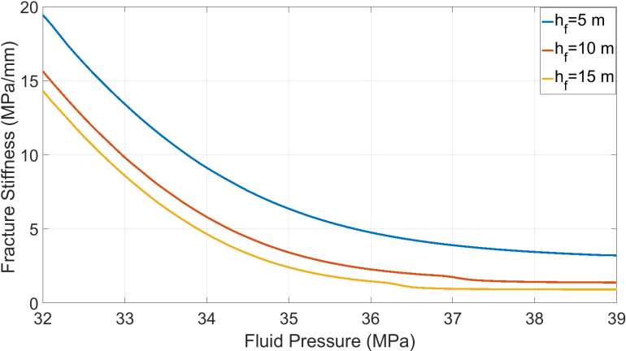
Fig.4.9 Fracture stiffness evolution for different fracture height with a PKN geometry
Fig.4.10 shows the fracturing pressure and its derivatives for different fracture height on G-function and square root of time plots. The results indicate that fracture height impacts the pressure decline trend significantly. Larger fracture height leads to later occurrence of the peak of the pressure derivative and this also increases the peak value of the pressure derivatives. The early-time straight lines of pressure derivatives are still controlled by initial fracture geometry.

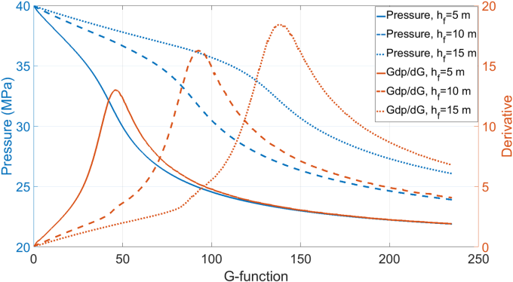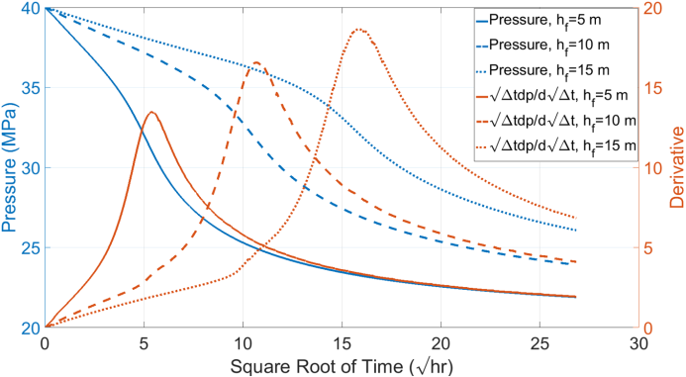
Fig.4.10 Pressure decline response for different fracture height with a PKN geometry
Fig.4.11 shows the fracture conductivity evolution for different fracture height with the same fracture roughness (i.e., identical contact parameters). It can be observed that fracture geometry does have an influence on fracture conductivity because it impacts non-local fracture closure process when the effective stress is small (non-uniform contact stress, higher towards the edges), but as the effective stress increases, it is the fracture roughness that dominates the evolution of fracture conductivity as the contact stress becomes more or less non-uniform across fracture surface. So even though fracture geometry may vary, the fracture conductivity is controlled by fracture roughness properties at the end. In other words, if we can obtain representative contact parameters from field data, we can use Eq.(11) to calculate the residual fracture width under a certain stress and correlate the residual fracture width to conductivity via the cubic law.
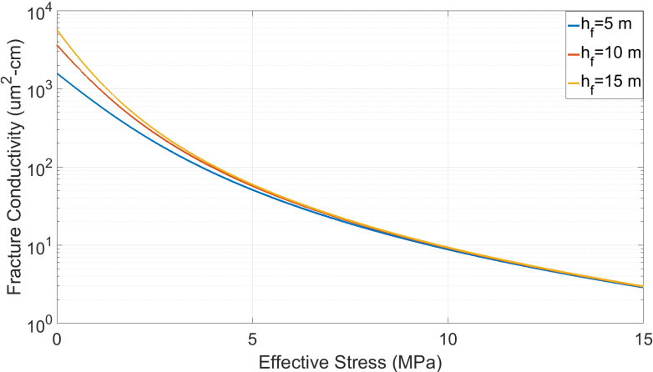
Fig.4.11 Fracture conductivity evolution for different fracture height
Fig.4.12 shows the fracturing pressure and its derivatives for different reservoir permeability on G-function and the square root of time plots. As expected, the pressure declines more rapidly when the reservoir permeability is large and the decline rate slows down as the difference between fracturing pressure and initial reservoir pressure becomes smaller.
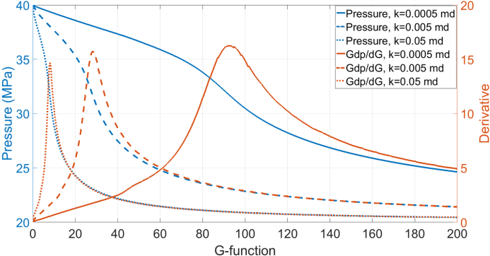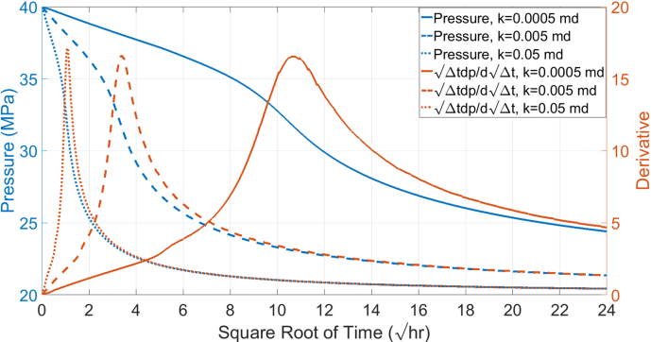
Fig.4.12 Pressure decline response for different reservoir permeability with a PKN geometry
Next, we examine the impact of wellbore storage. The water compressibility is assumed to be 4.35e-4 MPa-1. Fig.4.13 shows the fracture-wellbore system stiffness evolution for different wellbore volume. As can be seen, when fracturing pressure is high, fracture stiffness dominates the system stiffness. However, as fracturing pressure continues declining, the fracture become less and less compressible and the role of wellbore storage becomes apparent. In general, the larger the wellbore volume, the more gradual and slower the increase in system stiffness will be.
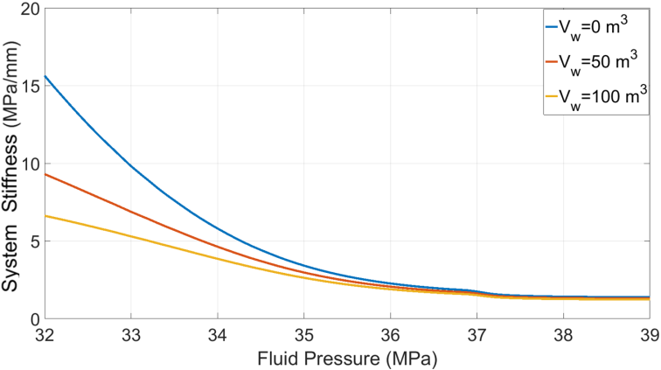
Fig.4.13 Fracture-wellbore system stiffness evolution for different wellbore volume with a PKN geometry
Fig.4.14 shows the corresponding fracturing pressure and its derivatives for different wellbore volumes on G-function and square root of time plots. It can be observed that larger wellbore volume leads to more gradual pressure decline trends. A larger wellbore volume also delays the occurrence of fracture closure and lowers the peak of the pressure derivative curve. It can be seen that wellbore storage has a small impact during early time of shut-in when the system stiffness is still dominated by initial fracture stiffness (determined by initial fracture geometry), however, as more and more of the fracture surface comes into contact and the fracture becomes stiffer, wellbore storage effects become apparent, and the after-flow of fluid from wellbore to fracture long after shut-in decelerates the pressure decline rate and extends the tail of the pressure derivative after it reaches the peak.

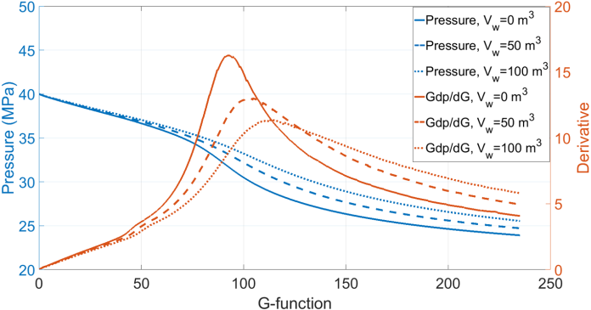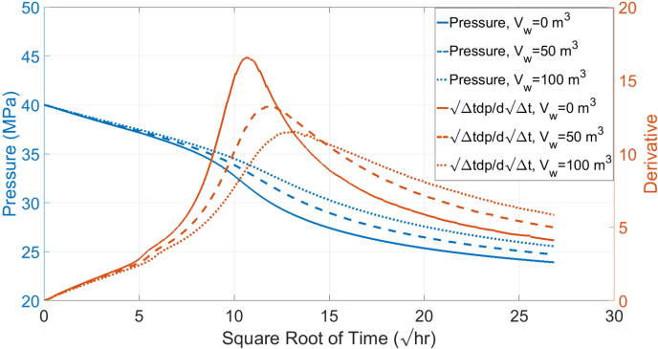
Fig.4.14 Pressure decline response for different wellbore volume with a PKN geometry
Fig.4.15 shows the fracturing pressure and its derivatives for different initial reservoir pressure on G-function and square root of time plots. It can be observed when the initial reservoir pressure is low; the pressure declines more rapidly. Because a lower reservoir pressure leads to a higher leak-off rate at the same ISIP. However, when the reservoir is over pressurized with high initial pore pressure, the pressure decline trend resembles a “normal-leak-off behavior”. In this case ($P_{0}$=28MPa), one can still notice that there is a subtle “bump” in the pressure derivatives that indicates an increase in fracture stiffness as reflected in Fig.5. For small values of $σ_{ref}$, this increase can be too small and gradual to be noticeable on G-function and square root of time plots. Nevertheless, the early-time pressure decline is still controlled by initial fracture geometry, and the late time pressure derivatives that extend the initial straight line to the peak is coincidence region where the effects of fracture pressure dependent leak-off (leads pressure derivative deviate downward) and the increase of fracture stiffness (leads pressure derivative deviate upward) counterbalance each other.
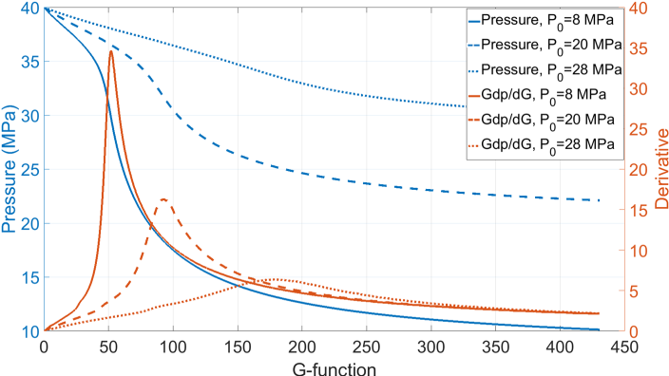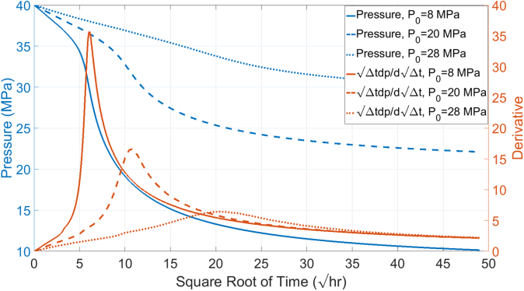
Fig.4.15 Pressure decline response for different initial reservoir pressure with a PKN geometry
From the above synthetic cases and analysis, it is clear that wellbore storage, reservoir properties and fracture stiffness/compliance govern the pressure decline response during DFIT. The fracture stiffness/compliance evolution is determined by rock mechanical properties, fracture geometry and surface roughness (i.e., represented by up-scaled contact parameters). In general, the wellbore storage is known in advance, reservoir properties can be estimated through laboratory experiments, well-logging and after closure analysis. Fracture dimensions with small injection volume can be constrained with proper geological, fracture propagation modeling and early-time stiffness estimation, so it is possible to obtain a good estimate of fracture roughness and infer un-propped fracture conductivity from the analysis of DFIT data. Unlike previous DFIT models, that only focus on one portion of the DFIT data, the DFIT model presented in this study has the capability to model the entire duration (before closure, after closure and the transitional periods), which significantly increases the reliability of data interpretation.

Chapter 5: Examples of Field Cases Analysis

5.1 FIELD CASE 1
The first field case analyzed comes from Horizontal Well-A drilled through a shale formation. The measured depth is around 5500 m and a diagnostic fracture injection test is conducted at the toe of the horizontal wellbore, with 2.35 m3 of water injected in 3 minutes, then the well was shut-in for 27 days. Fig.5.1 shows the pressure decline response on G-function and the square root of time plots. A closer look at the square root of time plot, shows that the pressure drops significantly during the first one hour of shut-in. By examining the pressure derivative curve, whose extrapolated value is not zero when ∆t=0, we can identify that the excessive pressure drop at the beginning is caused by tip extension and near-wellbore tortuosity. The apparent ISIP is 45.5 MPa while the true ISIP is 34.5 MPa. Remember net pressure is the pressure difference between the fluid pressure inside the fracture and closure pressure. In reality, the pressure measured at the wellhead can be much higher than expected during fracture propagation during the early time of shut-in period, because significant pressure drop can happen in the near-wellbore region and along the horizontal wellbore, due to friction and tortuous/complex fracture path that initiated from perforation clusters. So pressure data from this period cannot be used to infer fracturing parameters and reservoir properties.
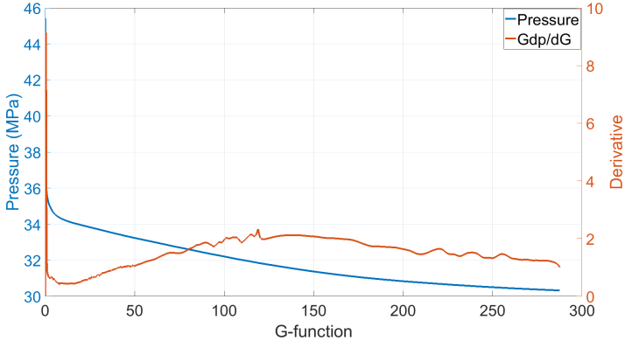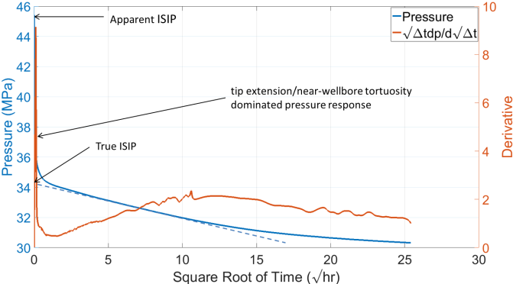
Fig.5.1 Pressure decline response from Well-A on G-function and square root of time plots
From the signature of pressure derivatives, the changes in fracture stiffness/compliance are undetectable, and the minimum in-situ stress is picked at 31.8 MPa from Fig.5.1. Even though Well-A was shut-in for nearly four weeks, pseudo-radial flow (-1 slope on log-log plot) is still absent, as shown in Fig.5.2. This is a clear evidence of extremely low formation permeability, without the interference of natural fractures.
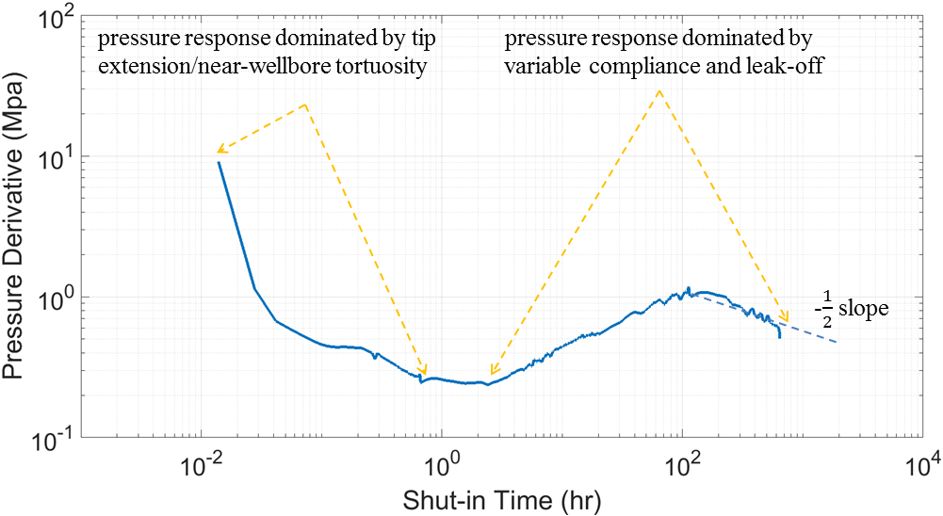
Fig.5.2 Log-log pressure derivative plot of Well-A
Without pseudo-radial flow, formation flow capacity cannot be determined independently with enough confidence using just after closure analysis alone. One has to analyze the whole spectrum of DFIT data to reach a consistent interpretation. Using late time data from the linear flow regime, the estimated initial pore pressure is 29.1 MPa. This indicates it is an over-pressurized reservoir.

From geological and petrophysical studies, it is known that the thickness of the target formation is 24.4 m with an average porosity of 0.07 and in-situ fluid viscosity of 0.257 cp, The Young’s modulus is 38.9 GPa, the Poisson’s ratio is 0.2 and formation total compressibility is 3e-3 MPa-1. Hydraulic fracture modeling indicates that the fracture is well contained within the target formation with penny-shaped fracture geometry, and the fracture radius is roughly 12 m. Based on this information, the pressure decline response can be matched globally using our DFIT model, from the end of tip extension/near-wellbore tortuosity dominated period to the end of the test.
Fig.5.3 shows the pressure decline response predicted by our DFIT model and field data on G-function and the square root of time plots. The results indicate that our simulated pressure matches extremely well with the field data for the entire duration of the test, excluding the first hour of shut-in. Our matched reservoir permeability is 220 nd, which is within the range of independent petrophysical measurements. The matched contact width and contact reference stress are 0.7 mm and 3 MPa, respectively, and Fig.5.4 shows the corresponding fracture and fracture-wellbore system stiffness, based on the matched fracture geometry, wellbore volume and contact parameters. Because the DFIT was conducted at the toe of a horizontal well, it is no surprise that the wellbore storage effect is significant, considering such a large contrast between the wellbore and fracture volume. We can also observe that the fracture stiffness has increased 10% when the pressure drops to 33 MPa, over 1 MPa above the true minimum in-situ stress.

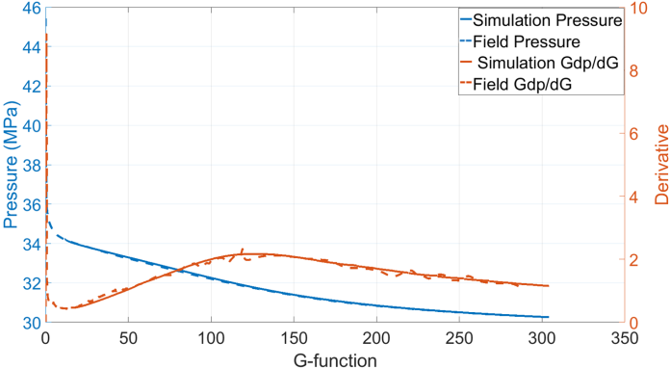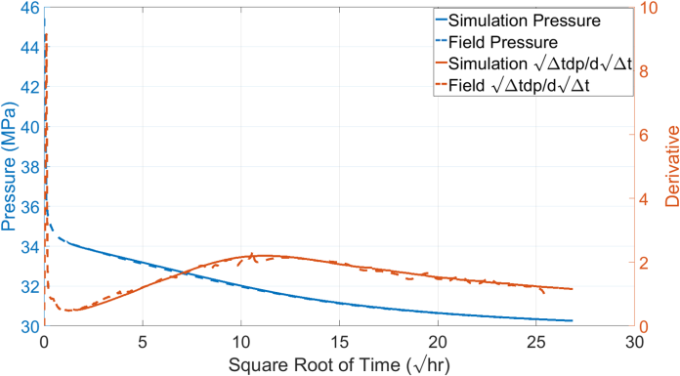
Fig.5.3 Matched pressure decline response for Well-A on G-function and square root of time plots
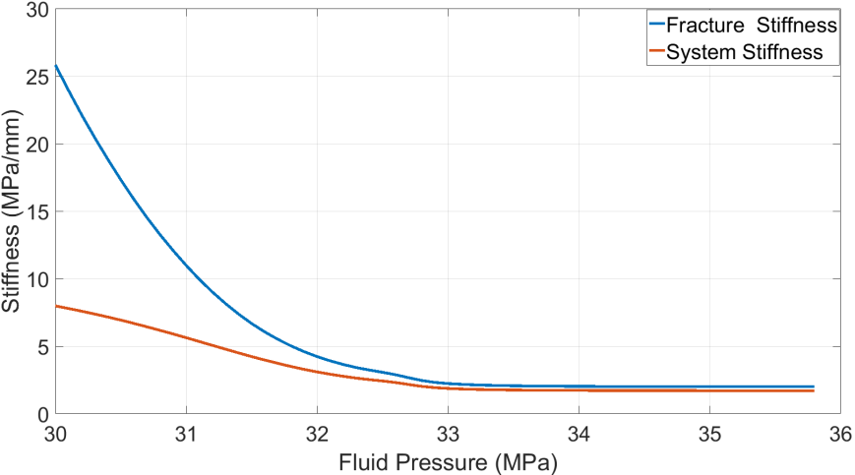
Fig.5.4 Matched fracture and fracture-wellbore system stiffness for Well-A
Similar to traditional pressure transient analysis, a good match of DFIT data does not guarantee that the interpretation is unique. In fact the history matched parameters can be just one set of many combinations that could result in a similar match. So uncertainty analysis can be done to obtain a range of parameters. In the field cases presented here, the fracture dimension has the most uncertainty. When we vary the fracture radius from 10 to 14m, to history match the DFIT data, the matched permeability ranges from 175 nd to 260 nd, the matched contact width ranges from 0.6 mm to 0.8 mm, and the matched contact reference stress ranges from 2.8 MPa to 3.4 MPa. The estimated un-propped fracture conductivity is shown in Fig.5.5 for different fracture dimensions. Similar to the previous synthetic cases, fracture conductivity declines more rapidly when the effective stress is small and then follows a semi-log relationship with effective stress as fracturing pressure declines further.

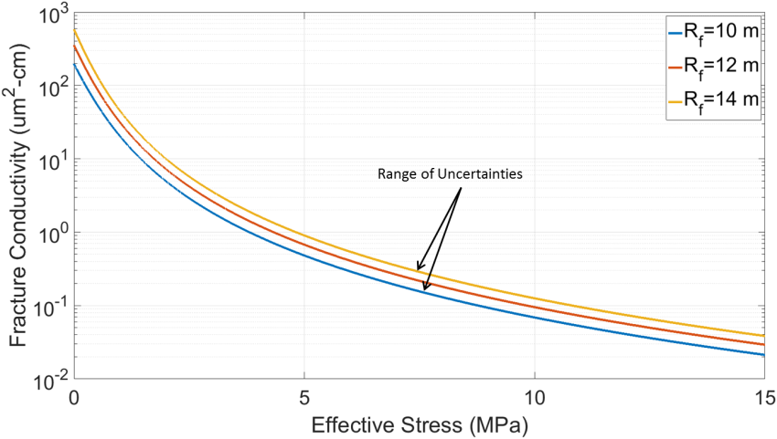
Fig.5.5 Estimated range of fracture conductivity and effective stress of an un-propped fracture for Well-A

5.2 FILED CASE 2

The second field case to be analyzed comes from a vertical well-B drilled through a shale formation. The total wellbore length is around 2000 m and a diagnostic fracture injection test is conducted with 4.7 m3 of water injection for 6 minutes, then the well was shut-in for 11 days. Fig.5.6 shows the pressure decline response on G-function and the square root of time plots.
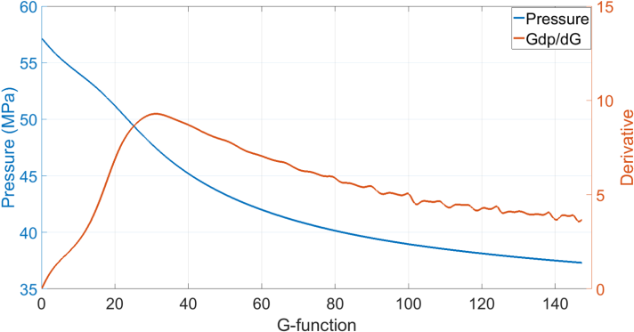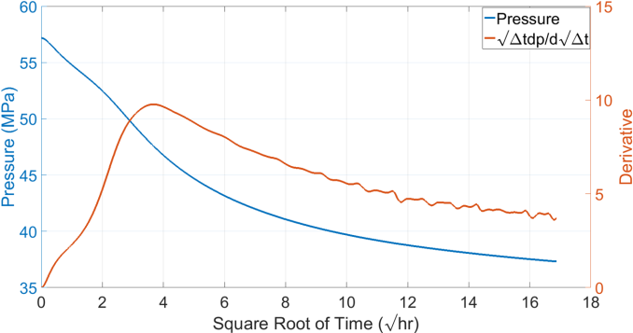
Fig.5.6 Pressure decline response from Well-B on G-function and square root of time plots
Because of the low permeability, no pseudo-radial flow signature can be observed, after-closure linear flow (-1/2 slope on the log-log plot) extends to the end of the test, as shown in Fig.5.7. Using late time data from the linear flow regime, the estimated initial pore pressure is 33.7MPa and the closure stress is picked at 52.4 MPa.
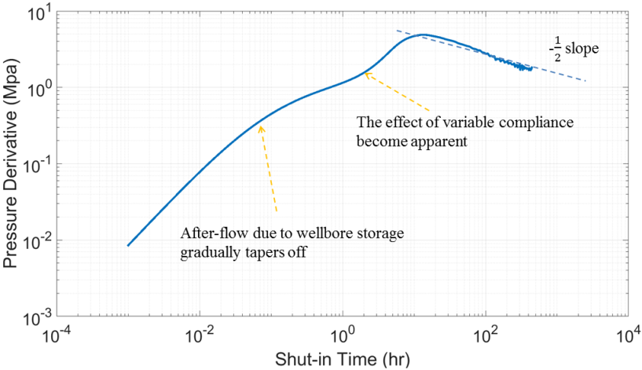
Fig.5.7 Log-log pressure derivative plot of Well-B
Geological and petrophysical studies indicate that the thickness of the target formation is 5 m with an average effective porosity of 0.03 and an in-situ fluid viscosity of 0.28 cp. The Young’s modulus is 39.5 GPa, the Poisson’s ratio is 0.25 and formation total compressibility is 1.9e-3 MPa-1. Hydraulic fracture modeling shows that the fracture is well contained within the target formation with roughly 200 m fracture half-length. Based on this information and assuming PKN geometry, the pressure decline response can be matched globally using our DFIT model by adjusting reservoir permeability and contact parameters. Fig.5.8 shows the predicted pressure decline response and field data on G-function and square root of time plots. Our matched reservoir permeability is 210 nd, and the matched contact width and contact reference stress are 1.2 mm and 1.1 MPa, respectively.
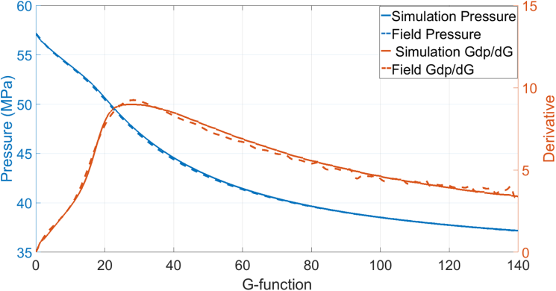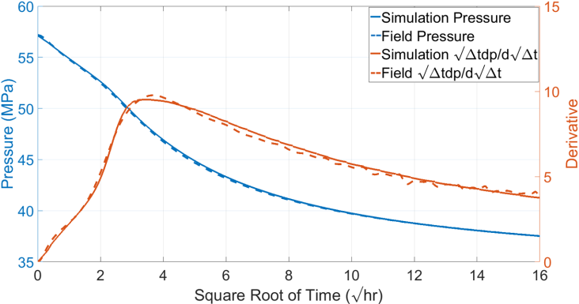
Fig.5.8 Matched pressure decline response for Well-B on G-function and square root of time plots
Fig.5.9 shows the corresponding fracture and fracture-wellbore system stiffness as a function of fluid pressure inside the fracture. It can be observed that both fracture and system stiffness increase gradually as pressure declines. Even though this test was conducted in a vertical well with a relatively moderate wellbore volume, the wellbore storage effect on the system stiffness is still significant. This is because the relative influence of wellbore storage depends not only on the ratio of wellbore to fracture volume, but it also on the fracture stiffness itself. For the same wellbore volume, the higher the fracture stiffness, the less compliant the fracture is and the compressed fluid in the wellbore plays a bigger role. In this field case, with fracture height is contained in 5 m, the initial fracture stiffness should be around 5.36 MPa/mm (calculated from Table 1).
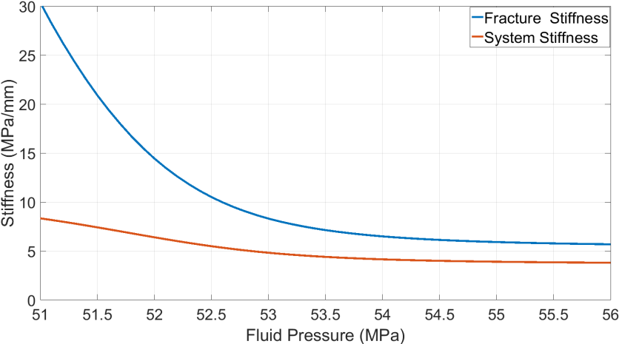
Fig.5.9 Matched fracture and fracture-wellbore system stiffness for Well-B
Even though we know that the fracture is bounded with a PKN type fracture geometry, there are still some uncertainties in fracture height. We vary the fracture height from 3 m to 7 m, and history match DFIT data, the matched permeability ranges from 124 nd to 300 nd, the matched contact width ranges from 0.8 mm to 1.5 mm, and the matched contact strength ranges from 0.9 MPa to 1.3 MPa. The ranges of estimated un-propped fracture conductivity are shown in Fig. 5.10.
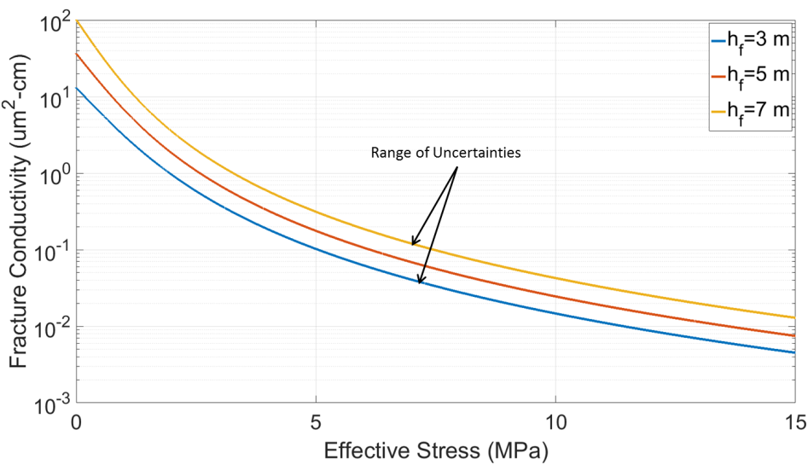
Fig.5.10 Estimated range of fracture conductivity and effective stress of un-propped fracture for Well-B.

References
Barr, D.T., 1991. Leading-edge analysis for correct simulation of interface separation and hydraulic fracturing. PHD dissertation, MIT, Cambridge, MA.
Barree, R. D. 1998. Applications of pre-frac injection/falloff tests in fissured reservoirs - field examples. Paper SPE 39932 presented at the SPE Rocky Mountain Regional/Low Permeability Reservoirs Symposium, Denver, CO, 5-8 April. http://dx.doi.org/10.2118/39932-MS.
Barree, R. D., H. Mukherjee. 1996. Determination of pressure dependent leakoff and its effect on fracture geometry. Paper SPE 36424 presented at the 71st Annual Technical Conference and Exhibition, Denver, 6-9 October. http://dx.doi.org/10.2118/36424-MS.
Barree, R. D., J. L. Miskimins, J. V. Gilbert. 2014. Diagnostic fracture injection tests: common mistakes, misuses, and misdiagnoses. SPE Production & Operations 30 (2):84-98, http://dx.doi.org/10.2118/169539-PA.
Barree, R.D., Barree, V.L. and Craig, D., 2009. Holistic fracture diagnostics: consistent interpretation of prefrac injection tests using multiple analysis methods. SPE Production & Operations, 24(03), pp.396-406. http://dx.doi.org/ 10.2118/107877-PA
Barton, N., S. Bandis, K. Bakhtar. 1985. Strength, deformation and conductivity coupling of rock joints. International Journal of Rock Mechanics and Mining Sciences & Geomechanics Abstracts 22 (3): 121-140, http://dx.doi.org/10.1016/0148-9062(85)93227-9.
Benelkadi, S., and Tiab, D. 2004. Reservoir Permeability Determination Using After-Closure Period Analysis of Calibration Tests. SPE Reservoir Evaluation & Engineering, Vol (7)03: 230- 237. http://dx.doi.org/10.2118/88640-PA
Bhide, R., Gohring, T., McLennan, J. and Moore, J., 2014. Sheared Fracture Conductivity. In Proceedings of 39th Workshop on Geothermal Reservoir Engineering
Castillo, J.L. 1987. Modified fracture pressure decline analysis including pressure-dependent leakoff. Paper SPE 164417 presented at the SPE/DOE Low Permeability Reservoir Symposium, Denver, CO, 18-19 May. http://dx.doi.org/10.2118/16417-MS.
Chipperfield, S. T. 2006. After-Closure Analysis to Identify Naturally Fractured Reservoirs. SPE Reservoir Evaluation & Engineering, Vol (9)01:50-60. http://dx.doi.org/10.2118/90002-PA
De Pater, C.J., Desroches, J., Groenenboom, J. and Weijers, L., 1996. Physical and numerical modeling of hydraulic fracture closure. SPE Production & Facilities, 11(02), pp.122-128. https://doi.org/10.2118/28561-PA
Economides, Michael J., Kenneth G. Nolte. 2000. Reservoir Stimulation, 3rd edition. Chichester, England; New York, John Wiley.
Fredd, C. N., McConnell, S. B., Boney, C. L., & England, K. W. 2000. Experimental Study of Hydraulic Fracture Conductivity Demonstrates the Benefits of Using Proppants. Paper SPE 60326 presented at the
SPE Rocky Mountain Regional/Low-Permeability Reservoirs Symposium and Exhibition, Denver, Colorado, 12-15 March. http://dx.doi.org/10.2118/60326-MS
Fu, Y., Dehghanpour, H., Ezulike, D. O., and Jones, R. S. 2017. Estimating Effective Fracture Pore Volume From Flowback Data and Evaluating Its Relationship to Design Parameters of Multistage-Fracture Completion. SPE Production & Operations (PrePrint). https://doi.org/10.2118/175892-PA
Gringarten, A. C., Ramey, H. J., and Raghavan, R. 1974. Unsteady-State Pressure Distributions Created by a Well with a Single Infinite-Conductivity Vertical Fracture. SPE Journal. Vol(14)04:347-360. http://dx.doi.org/10.2118/4051-PA
Gu, H., Elbel, J. L., Nolte, K. G., Cheng, A. .-D., and Abousleiman, Y. 1993.Formation Permeability Determination Using Impulse-Fracture Injection. Paper SPE 25425 presented at the SPE Production Operations Symposium, Oklahoma City, 21-23 March. https://doi.org/10.2118/25425-MS
Hawkes, R., Bachman, R. C., Walters, D. A., Toussaint, F. L., and Settari, T. 2012. Reappraisal of the G Time Concept in Mini-Frac Analysis. Paper SPE 160169 presented at the SPE Annual Technical Conference and Exhibition, San Antonio, Texas, USA, 8-10 October. https://dx.doi.org/10.2118/160169-MS
Koning, E.J.L. and Niko, H., 1985, January. Fractured Water-Injection Wells: A Pressure Falloff Test for Determining Fracture Dimensions. Paper SPE 14458 presented at the SPE Annual Technical Conference and Exhibition, Las Vegas, Nevada, 22-26 September. https://doi.org/10.2118/14458-MS
Liu, G., Ehlig-Economides, C. and Sun, J. 2016. Comprehensive Global Fracture Calibration Model. Paper SPE 181856 presented at the SPE Asia Pacific Hydraulic Fracturing Conference, Beijing, China, August 24-26. http://dx.doi.org/10.2118/181856-MS
Loughry, D., Epps, D. and Forrest, J., 2015. Using Pad ISIP, DFIT, and ESP Data to Generate a Pore Pressure Model for the Midland Basin. Paper presented at the Unconventional Resources Technology Conference, San Antonio, Texas, USA, 20-22 July. https://doi.org/10.15530/URTEC-2015-2162973
Marongiu-Porcu, Matteo, Albertus Retnanto, Michael J. Economides, Christine Ehlig-Economides. 2014. Comprehensive fracture calibration test design. Paper SPE 168634 presented at the SPE Hydraulic Fracturing Technology Conference, The Woodlands, TX, February 4-6. http://dx.doi.org/10.2118/168634-MS
Mayerhofer, M. J., and Economides, M. J. 1997. Fracture-Injection-Test Interpretation: Leakoff Coefficient vs. Permeability. SPE Production & Facilities. Vol (12) 04:231-236. http://dx.doi.org/10.2118/28562-PA
Mayerhofer, M. J., Ehlig-Economides, C. A., and Economides, M. J. 1995. Pressure Transient Analysis of Fracture Calibration Tests. Journal of Petroleum Technology. Vol(47)03:229-234. http://dx.doi.org/10.2118/26527-PA
McClure, M.W. 2017. The Spurious Deflection on Log-Log Superposition Time Derivative Plots of Diagnostic Fracture. SPE Reservoir Evaluation & Engineering. 20(04):1045-1055. https://doi.org/10.2118/186098-PA
McClure, M.W., Jung, H., Cramer, D.D. and Sharma, M.M., 2016. The Fracture Compliance Method for Picking Closure Pressure from Diagnostic Fracture-Injection Tests. SPE Journal 21(04):1321-1339. http://dx.doi.org/10.2118/179725-PA
Mirani, A., Marongiu-Porcu, M., Wang, H. and Enkababian, P., 2017. Production-Pressure-Drawdown Management for Fractured Horizontal Wells in Shale-Gas Formations. SPE Reservoir Evaluation & Engineering. (In Press). https://doi.org/10.2118/181365-PA
Nolte, K. G. 1979. Determination of Fracture Parameters from Fracturing Pressure Decline. Paper 8341 presented at the SPE Annual Technical Conference and Exhibition, Las Vegas, Nevada, 23-26 September. http://dx.doi.org/10.2118/8341-MS
Nolte, K. G. 1986. A General Analysis of Fracturing Pressure Decline with Application to Three Models. SPE Formation Evaluation. Vol (1) 06:571-583. http://dx.doi.org/10.2118/12941-PA
Nolte, K. G., Maniere, J. L., and Owens, K. A. 1997. After-Closure Analysis of Fracture Calibration Tests. Paper SPE 38676 presented at the SPE Annual Technical Conference and Exhibition, San Antonio, Texas, 5-8 October. http://dx.doi.org/10.2118/38676-MS
Potocki, D. J. 2012. Understanding Induced Fracture Complexity in Different Geological Settings Using DFIT Net Fracture Pressure. Paper SPE 162814 presented at the SPE Canadian Unconventional Resources Conference, Calgary, Alberta, Canada, 30 October-1 November. http://dx.doi.org/10.2118/162814-MS
Ramurthy, M., Barree, R.D., Kundert, D.P., Petre, J.E. and Mullen, M.J., 2011. Surface-area vs. conductivity-type fracture treatments in shale reservoirs. SPE Production & Pperations, 26(04), pp.357-367. https://doi.org/10.2118/140169-PA
Sakaguchi, K., Tomono, J., Okumura, K., Ogawa, Y. and Matsuki, K., 2008. Asperity height and aperture of an artificial tensile fracture of metric size. Rock Mechanics and Rock Engineering, 41(2), pp.325-341. http://dx.doi.org/ 10.1007/s00603-005-0102-3
Schiesser, W.E. and Griffiths, G.W., 2009. A compendium of partial differential equation models: method of lines analysis with Matlab. Cambridge University Press.
Sneddon, I. N. and Lowengrub, M., Crack Problems in the Classical Theory of Elasticity. John Wiley & Sons, Inc., New York, 1969
Soliman, M. Y., Craig, D. P., Bartko, K. M., Rahim, Z., and Adams, D. M. 2005. Post-Closure Analysis to Determine Formation Permeability, Reservoir Pressure, Residual Fracture Properties. Paper SPE 93419 presented at the SPE Middle East Oil and Gas Show and Conference, Kingdom of Bahrain,12-15 March. http://dx.doi.org/10.2118/93419-MS
Soliman, M. Y., Shahri, M., and Lamei, H. 2013. Revisiting the Before Closure Analysis Formulations in Diagnostic Fracturing Injection Test. Paper SPE 163869 presented at the SPE Hydraulic Fracturing Technology Conference, The Woodlands, Texas, USA, 4-6 February. http://dx.doi.org/10.2118/163869-MS
Soliman, M.Y. and Kabir, C.S., 2012. Testing unconventional formations. Journal of Petroleum Science and Engineering, 92, pp.102-109. https://doi.org/10.1016/j.petrol.2012.04.027
Soliman, M.Y., Miranda, C., and Wang, H.M. 2010. Application of After-Closure Analysis to a Dual-Porosity Formation, to CBM, and to a Fractured Horizontal Well. SPE Prod & Oper 25 (4): 472–483. SPE-124135-PA. http://dx.doi.org/10.2118/124135-PA.
Valko´, P. P., and Economides, M. J. 1999. Fluid-Leakoff Delineation in High-Permeability Fracturing. SPE Production & Facilities. Vol (14)02:110-116. http://dx.doi.org/10.2118/56135-PA
van Dam, D.B., de Pater, C.J. and Romijn, R., 2000. Analysis of Hydraulic Fracture Closure in Laboratory Experiments. SPE Production & Facilities,15(03), pp.151-158. http://dx.doi.org/10.2118/65066-PA
van den Hoek, P., 2017. A Simple Unified Pressure-Transient-Analysis Method for Fractured Waterflood Injectors and Minifractures in Hydraulic-Fracture Stimulation. SPE Production & Operations. (In Press). https://doi.org/10.2118/181593-PA
van den Hoek, P.J., 2005. Dimensions and Degree of Containment of Waterflood-Induced Fractures from Pressure Transient Analysis. SPE Reservoir Evaluation & Engineering, 8(05), pp.377-387. https://doi.org/10.2118/84289-PA
Wang, H and Sharma, M.M. 2017b. New Variable Compliance Method for Estimating Closure Stress and Fracture Compliance from DFIT data. Paper SPE 187348 presented at the SPE Annual Technical Conference and Exhibition held in San Antonio, TX, USA, 09 – 11 October. http://dx.doi.org/10.2118/ 187348-MS
Wang, H and Sharma, M.M. 2018. Estimating Unpropped Fracture Conductivity and Compliance from Diagnostic Fracture Injection Tests. Paper SPE 189844 presented at the SPE Hydraulic Fracturing Technology Conference and Exhibition, The Woodlands, Texas, 23 - 25 Jan. http://dx.doi.org/10.2118/ 189844-MS.
Wang, H. and Sharma, M.M. 2017a. A Non-Local Model for Fracture Closure on Rough Fracture Faces and Asperities. Journal of Petroleum Science and Engineering, 154, 425-437. https://dx.doi.org/10.1016/j.petrol.2017.04.024
Wang, H., Marongiu-Porcu, M., and Economides, M. J. 2016. SPE-168600-PA. Poroelastic and Poroplastic Modeling of Hydraulic Fracturing in Brittle and Ductile Formations, Journal of SPE Production & Operations, 31(01): 47–59. http://dx.doi.org/10.2118/168600-PA
Wang, H., Marongiu-Porcu, M., and Economides, M. J. 2016. SPE-168600-PA. Poroelastic and Poroplastic Modeling of Hydraulic Fracturing in Brittle and Ductile Formations, Journal of SPE Production & Operations, 31(01): 47–59. http://dx.doi.org/10.2118/168600-PA
Wang, H., Yi,S., and Sharma, M. M. 2018. A Computational efficient method for Solving Crack Closure and Contact Problems Using Superposition Method. Theoretical and Applied Fracture Mechanics (In Press). https://doi.org/10.1016/j.tafmec.2017.09.009
Warpinski, N.R., Branagan, P.T., Engler, B.P., Wilmer,R., and Wolhart, S.L. 2002. Evaluation of a downhole tiltmeter array for monitoring hydraulic fractures. International Journal of Rock Mechanics and Mining Sciences, Vol (34)3-4: 329.e1–329.e13. http://dx.doi.org/ 10.1016/S1365-1609(97)00074-9
Warpinski, N.R., Lorenz, J.C., Branagan, P.T., Myal, F.R. and Gall, B.L., 1993. Examination of a Cored Hydraulic Fracture in a Deep Gas Well (includes associated papers 26302 and 26946). SPE Production & Facilities, 8(03), pp.150-158. http://dx.doi.org/10.2118/22876-PA
Wells, O.L. and Davatzes N.C., 2015. The History of Dilation Across Natural Fractures Due to Evolving Surface Roughness. In Proc. 40th Workshop on Geothermal Reservoir Engineering
Willis-Richards, J., K. Watanabe, H. Takahashi. 1996. Progress toward a stochastic rock mechanics model of engineered geothermal systems. Journal of Geophysical Research 101 (B8): 17481-17496, http://dx.doi.org/10.1029/96JB00882.
Zhang, J., Kamenov, A., Hill, A.D. and Zhu, D., 2014. Laboratory Measurement of Hydraulic-Fracture Conductivities in the Barnett Shale. SPE Production & Operations, 29(03), pp.216-227. http://dx.doi.org/10.2118/163839-PA
Zou, Y., Ma, X., Zhang, S., Zhou, T., Ehlig-Economides, C. and Li, H., 2015. The Origins of Low‐Fracture Conductivity in Soft Shale Formations: An Experimental Study. Energy Technology, 3(12), pp.1233-1242. https://dx.doi.org/10.1002/ente.201500188

